SIGNALS

USE VISUAL SIGNALING TECHNIQUES
071-326-0608

CONDITIONS

Given a requirement to use visual signals while mounted.

STANDARDS

Execute the proper procedures for each visual signal given.

TRAINING AND EVALUATION
Training Information Outline

1. Visual signals are any means of communication that require sight and can be used to quickly transmit planned messages over short distances. This includes the devices and means used for the recognition and identification of friendly forces.

2. The most common types of visual signals are arm-and-hand, flag, pyrotechnic, and ground-to-air signals. However, soldiers are not limited to the types of signals discussed and may use what is available. Chemical light sticks, flashlights, and other items can be used provided their use is standardized within a unit and understood by soldiers and units working in the area. The only limit is the soldier’s initiative and imagination.

3. Visual signals have certain limitations:
a. The range and reliability of visual communications are significantly reduced during poor visibility and when terrain restricts observation.
b. They may be misunderstood.
c. They are vulnerable to enemy interception and may be used for deception purposes.

4. Signals illustrated with a single arrowhead indicate that the signal is not continually repeated. However, it may be repeated at intervals until acknowledged or the desired action is executed. Signals illustrated with double arrowheads are repeated continually until acknowledged or until the desired action is taken. Signals are illustrated as normally seen by the viewer. Some signals are illustrated in oblique, right-angle, or overhead views for clarity.
a. Leaders of mounted units use arm-and-hand signals to control individual vehicle and platoon movements. When distances between vehicles increase, flags can be used as extensions of the arms to give the signals. From some vehicles, such as the M2 Bradley, the arm-and-hand signals will be partly hidden. Signals in task 071-326-0600, Use Visual Signaling Techniques While Dismounted, are also used by mounted troops when dismounted.
b. The following illustrations depict signals for combat formations, battle drills, and movement techniques.
(1) Formation signals (Figures 1 and 2).

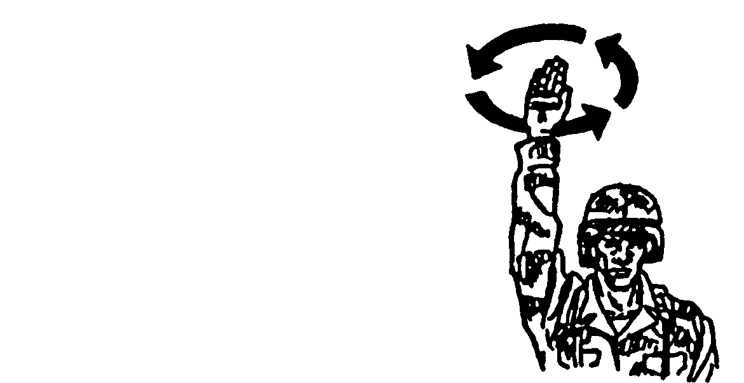
Raise one arm above the head and rotate it in a small circle.

Figure 1. Coil.

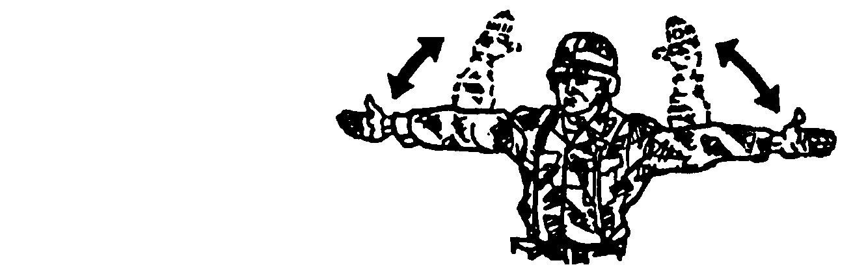
Extend the arms parallel to ground. Bend the arms until the forearms are perpendicular. Repeat.

Figure 2. Herringbone.

(2) Drill signals (Figures 3 through 9). Drills are a rapid, reflexive response executed by a small unit. These signals are used to initiate drills. They are used mounted or dismounted.

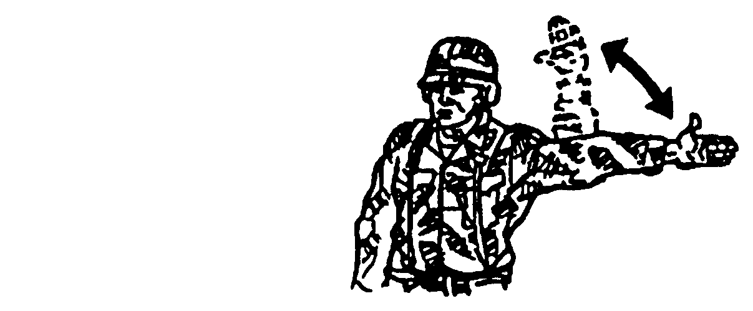
Extend the left arm parallel to the ground. Bend the arm until the forearm is perpen-dicular. Repeat.

Figure 3. Contact left.

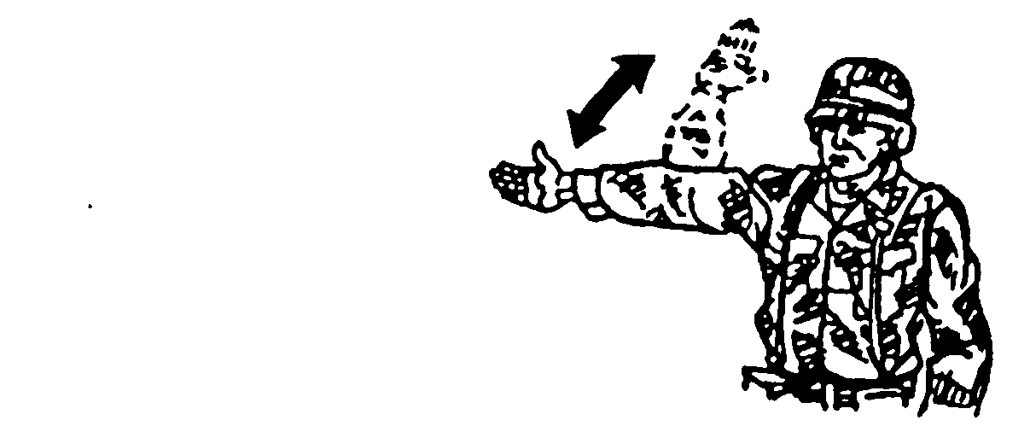
Extend the right arm parallel to the ground. Bend the arm until the forearm is perpen-dicular. Repeat.

Figure 4. Contact right.

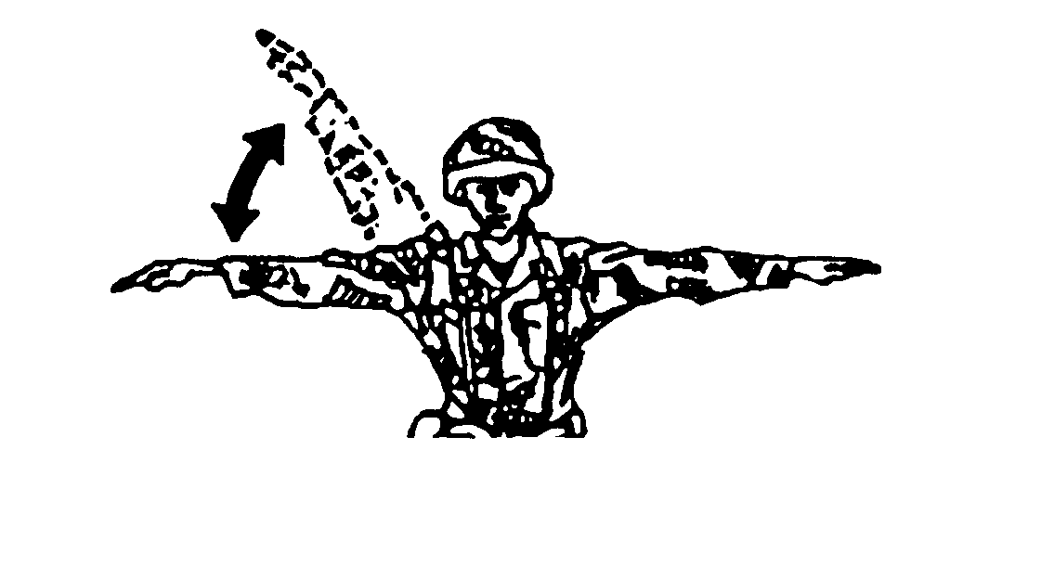
Extend both arms parallel to the ground. Raise the right arm until it is overhead. Repeat.

Figure 5. Action left.

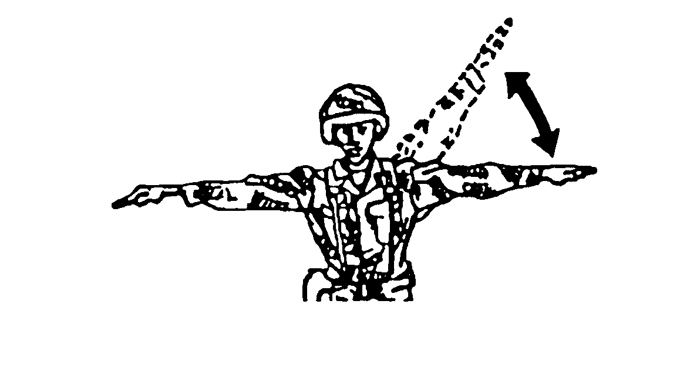
Extend both arms parallel to the ground. Raise the left arm until it is overhead. Repeat.

Figure 6. Action right.

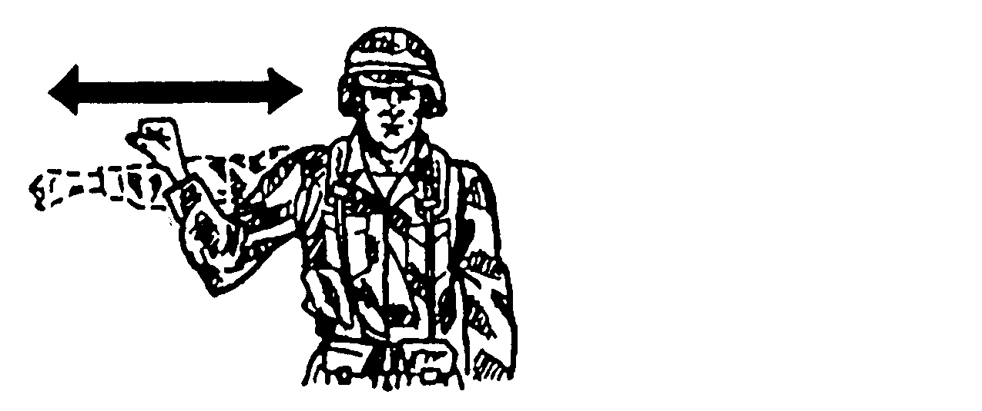
Raise the fist to shoulder level and thrust it several times in the desired direction of action.

Figure 7. Action front (right, left, or rear),
fight on foot, or assault fire (dismounted troops).

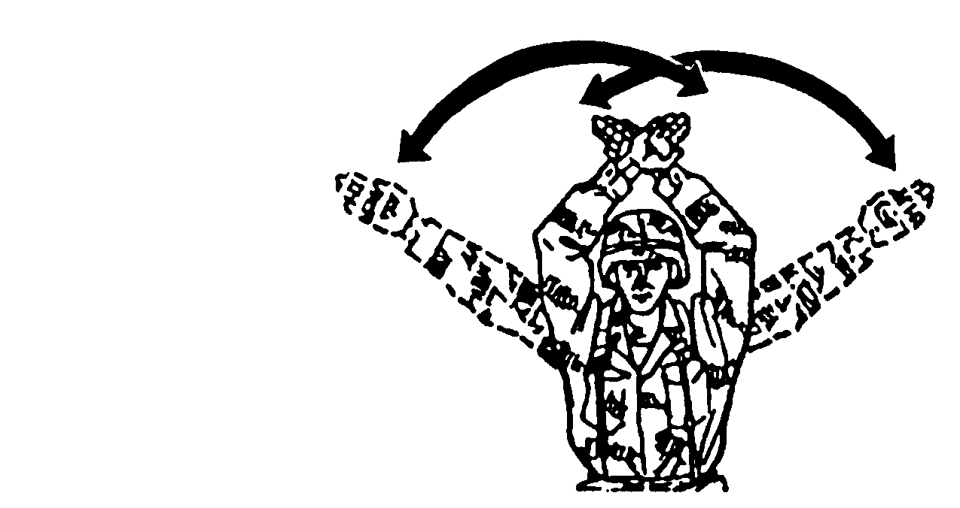
Bend the arms with fore-arms at a 45-degree angle. The forearms are crossed. Repeat.

Figure 8. Air attack.

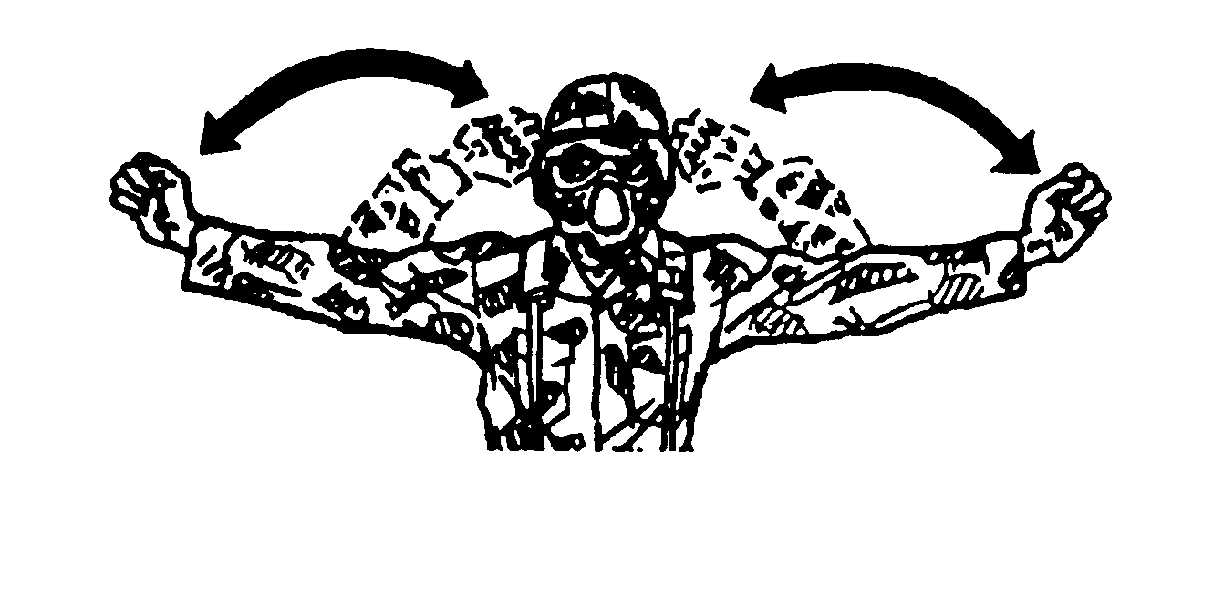
Extend the arms and fists. Bend the arms to the shoulders. Repeat.

Figure 9. Nuclear, biological, chemical attack.

(3) Movement technique signals (Figures 10 through 14).

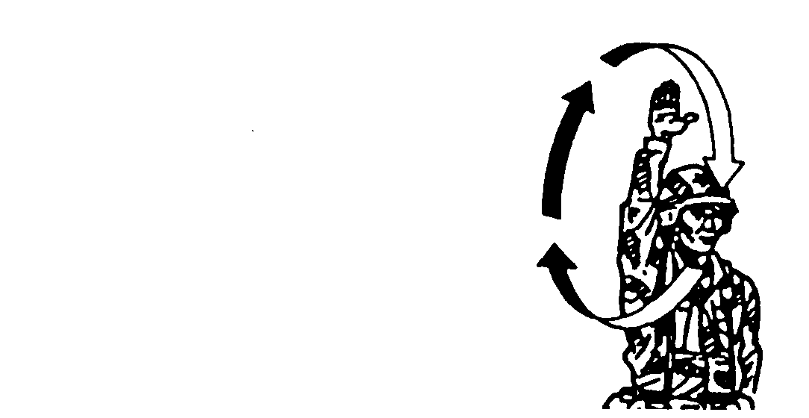
Extend the arm over-head and swing it in a circle from the shoulder.

Figure 10. Traveling.

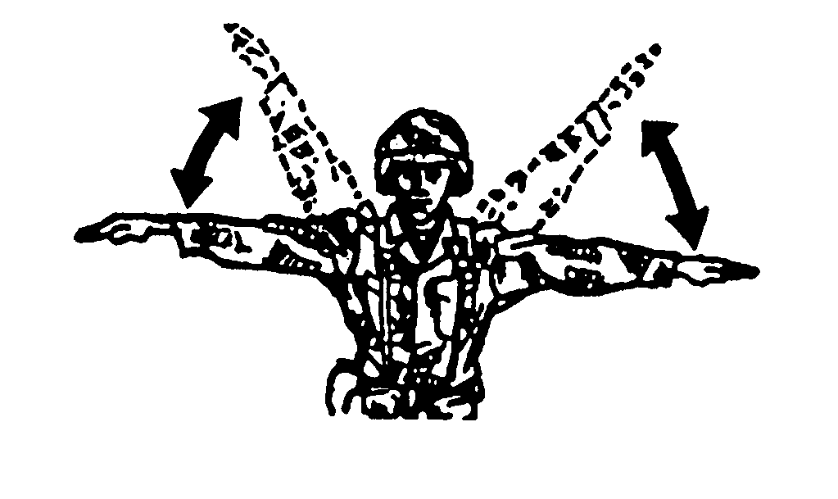
Extend both arms and raise them up and down.

Figure 11. Traveling overwatch.

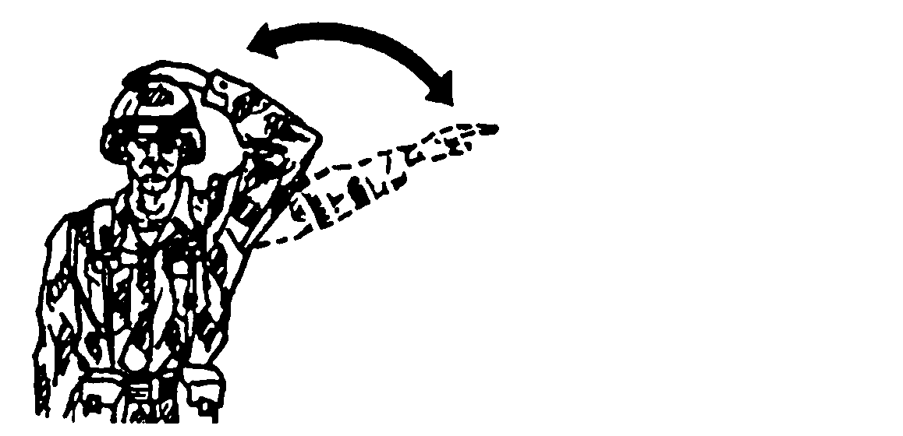
Extend one arm to a 45-degree angle. Bend the arm and tap the helmet. Repeat

Figure 12. Bounding overwatch, cover my move.
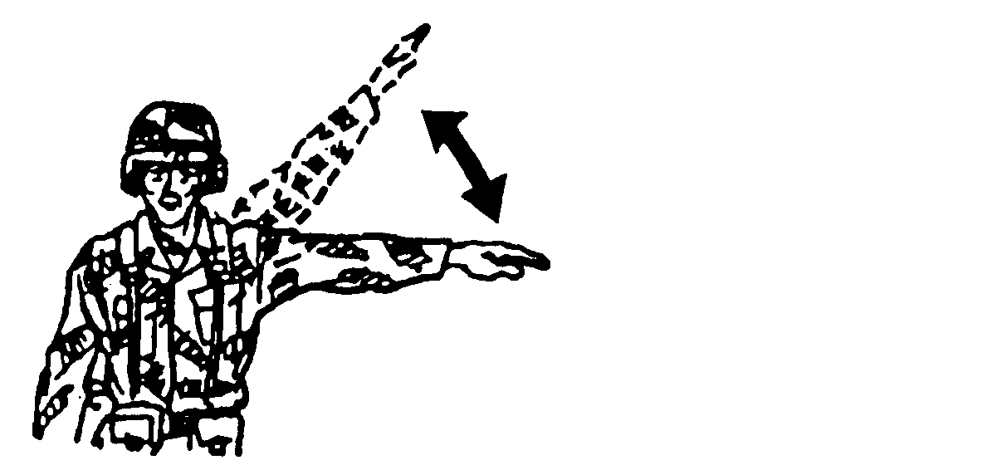
Extend the arm to the left and raise it up and down.

Figure 13. Move to left.

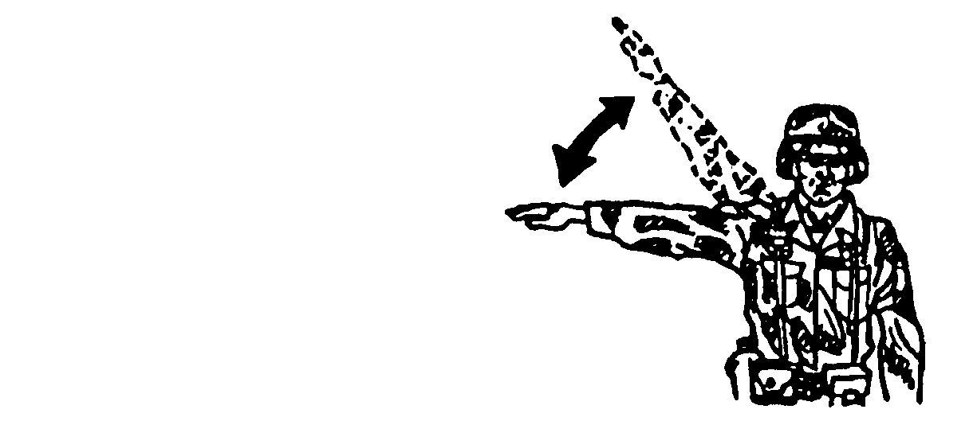
Extend the arm to the right and raise it up and down.

Figure 14. Move to right.

(4) Signals to control vehicle drivers and crews (Figures 15 through 36). These are the arm-and-hand and light signals used to guide and direct vehicles. Flashlights are used at night. Blue filters should be used with flashlights to help prevent detection by light- and heat-detecting devices. Red filters should be used when preserving the driver’s night vision is more important. Chemical lights can also be used and have less effect on the driver’s night vision.
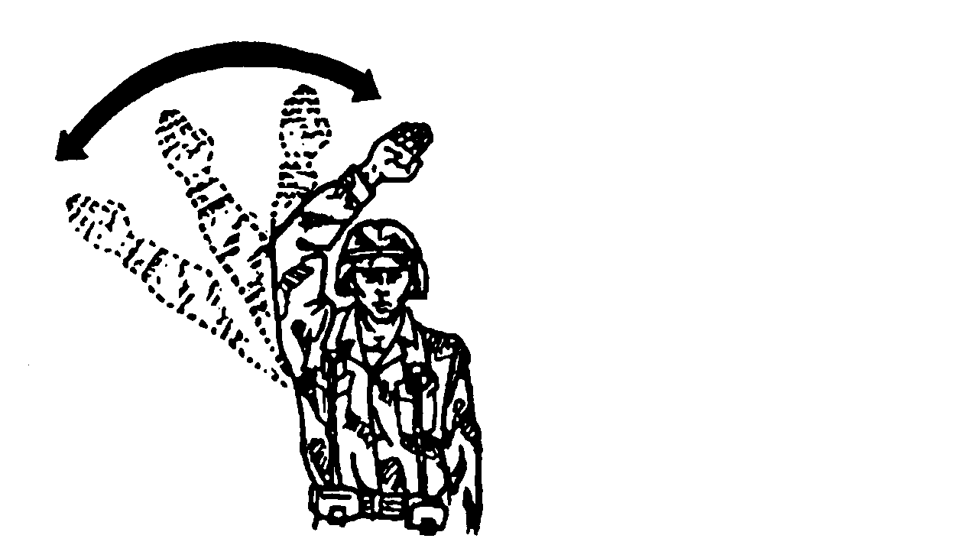
Extend the arm sideways, slightly above the horizon-tal, palm to the front. Wave the arm to and from the head several times.

Figure 15. Attention.

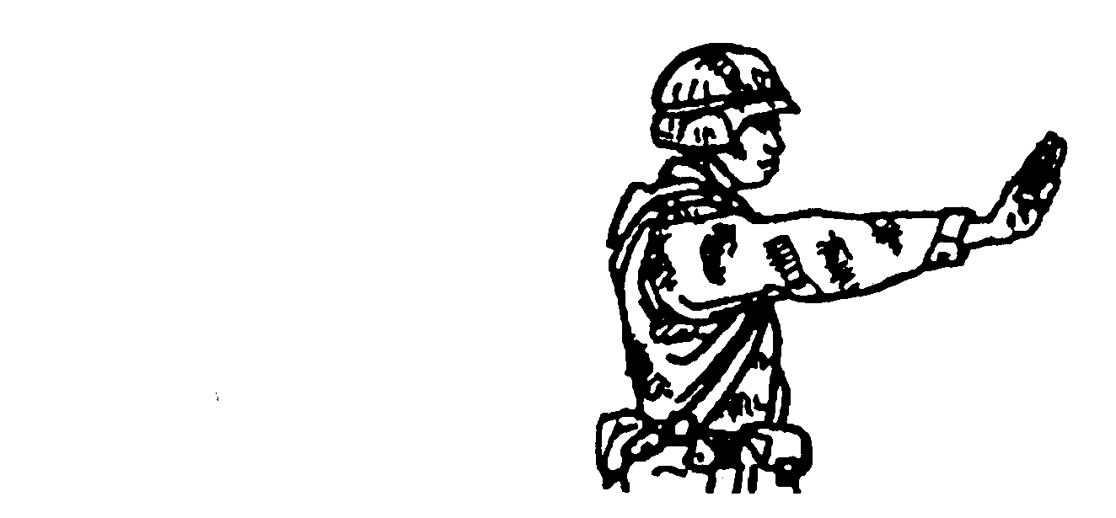
Extend the arm toward the person being signaled; then raise the arm slightly above horizontal, palm outward.

Figure 16. I am ready, or ready to move, are you ready?

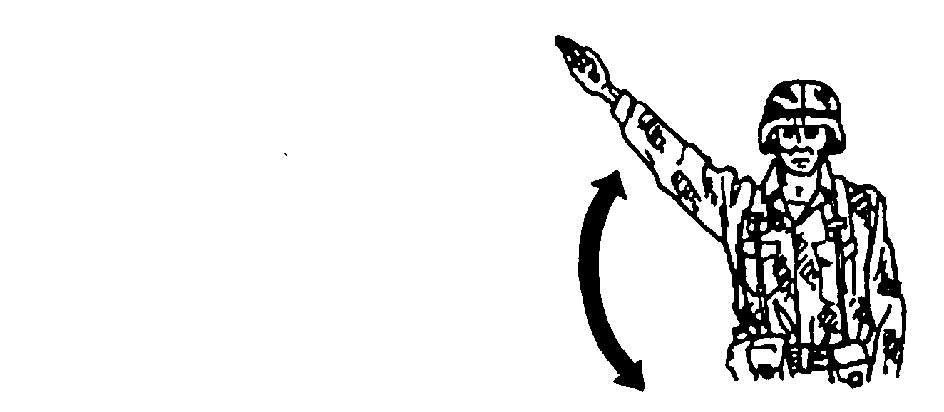
Make two or three movements upward with the open hand, palm up.

Figure 17. Mount.

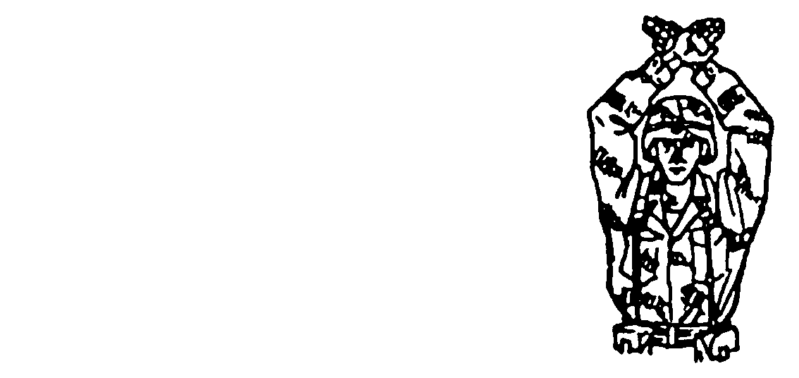
Raise both arms and cross wrists above the head, palms to the front.

Figure 18. Disregard previous command, or as you were.

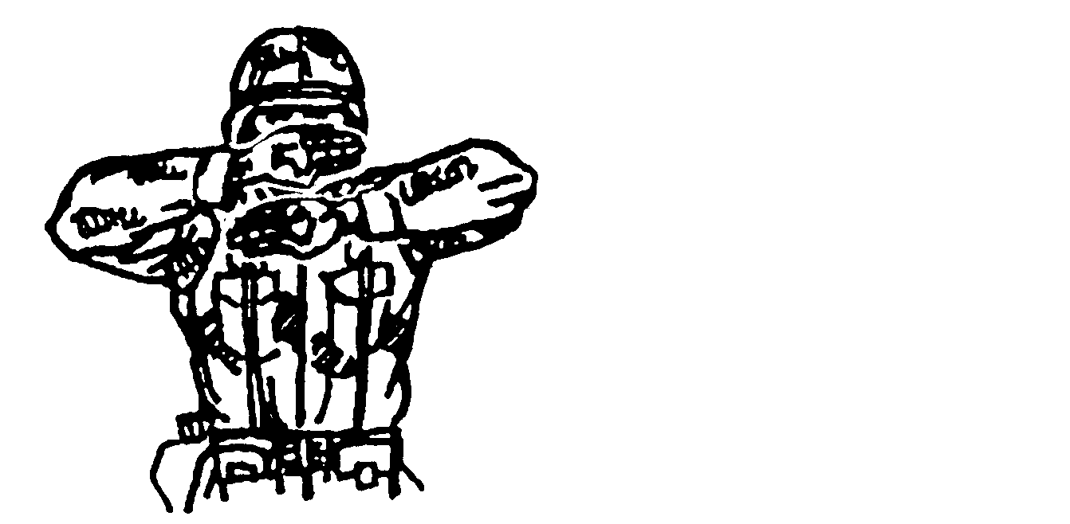
Raise both arms sideways to the horizontal; bend both arms at the elbows and place both hands across the face, palms to the front.

Figure 19. I do not understand.

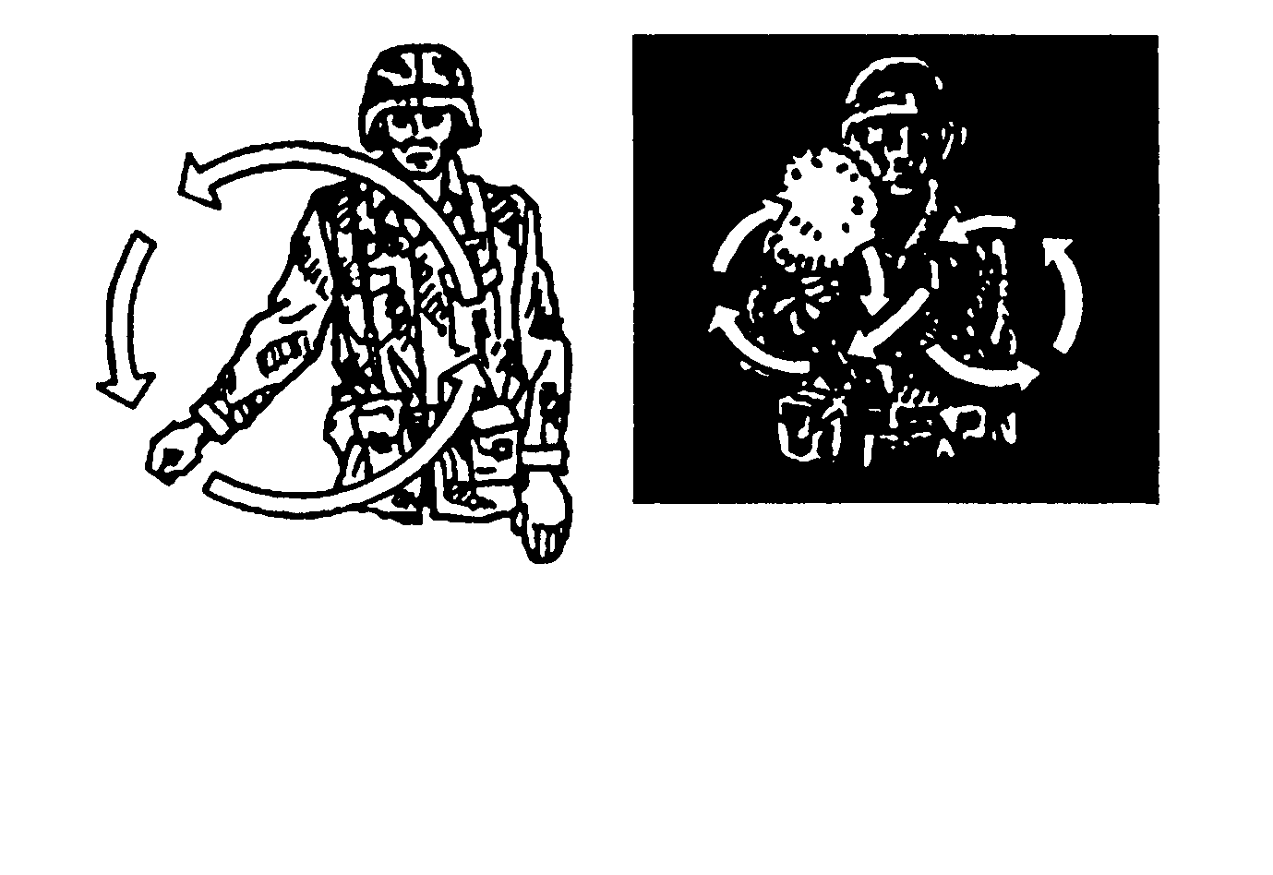
DAY

Simulate cranking of engines by making a fist and moving the army in a circular motion at waist level.
NIGHT

Move a light to describe a horizontal figure 8 in a vertical plane in front of the body.

Figure 20. Start engine, or prepare to move.

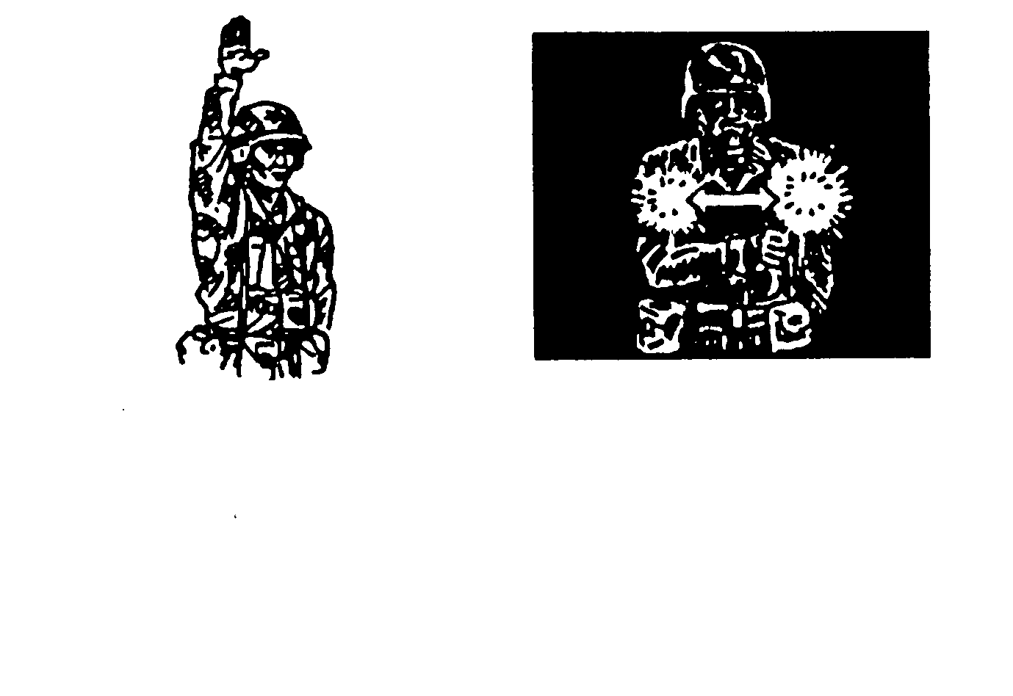
DAY

Raise the hand upward to the full extent of the arm, palm to the front. Hold that position until the signal is understood.
NIGHT

Move a light horizontally back and forth several times across the path of approaching traffic to stop vehicles. Use the same signal to stop engines.
NOTE: For alternate signal to stop vehicles, see Figure 34.

Figure 21. Halt, or stop.
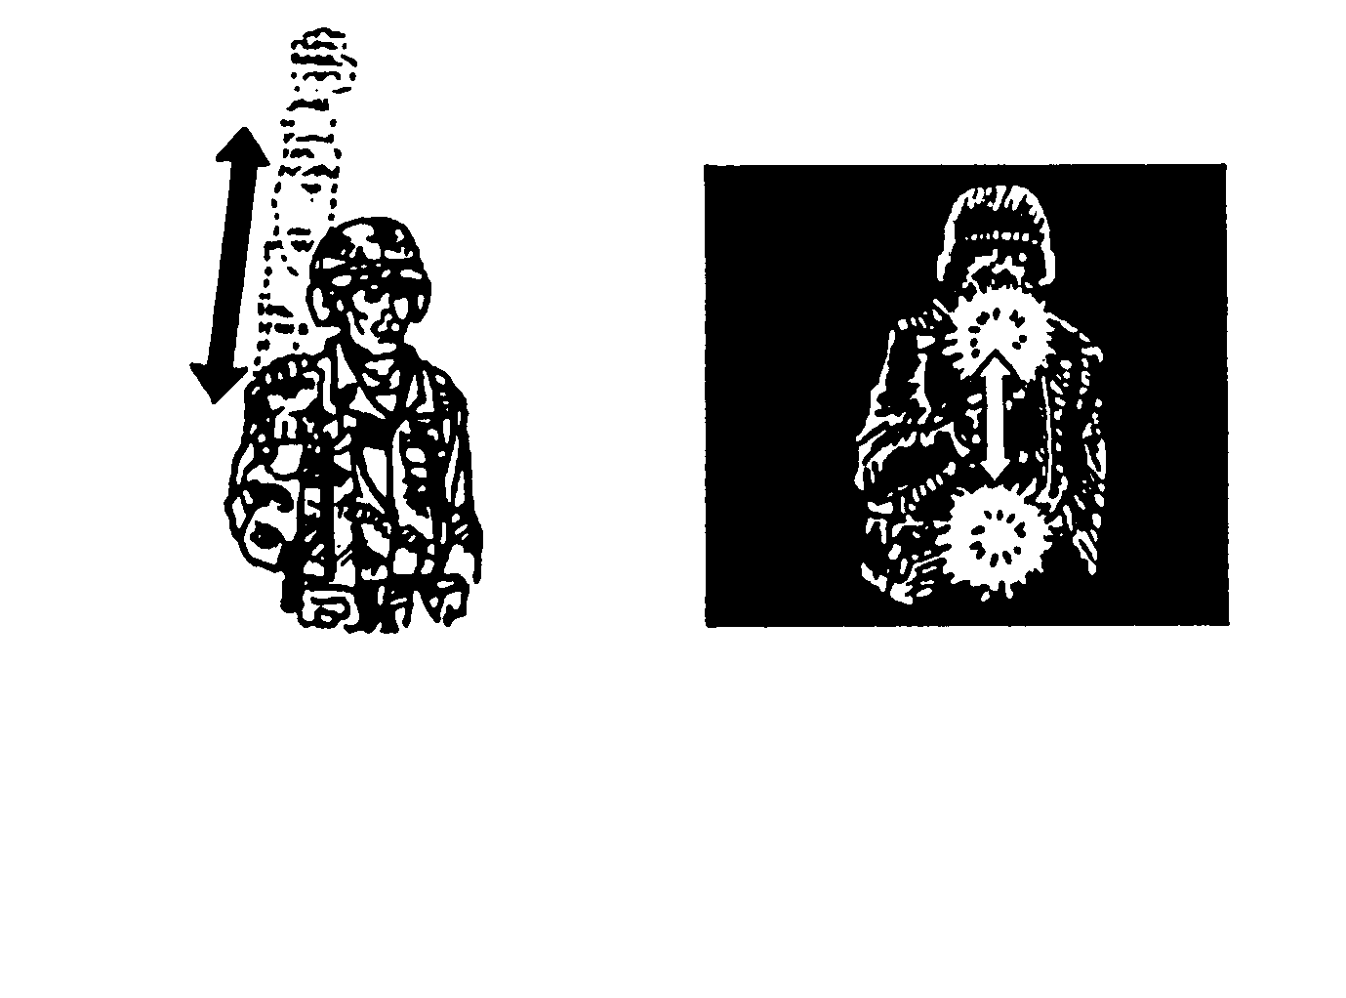
DAY

Raise the fist to shoulder level; thrust the fist upward to the full extent of the arm and back to shoulder level rapidly several times.
NIGHT

Move a light vertically several times in front of the body.

Figure 22. Increase speed.

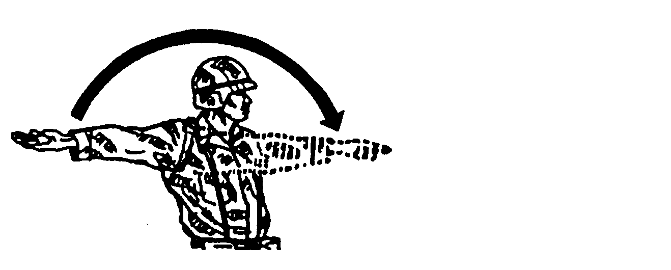
Face the direction of movement; hold the arm extended to the rear; swing the arm overhead and forward in the direction of movement (hold at the horizontal), palm down.

Figure 23. Advance or move out.

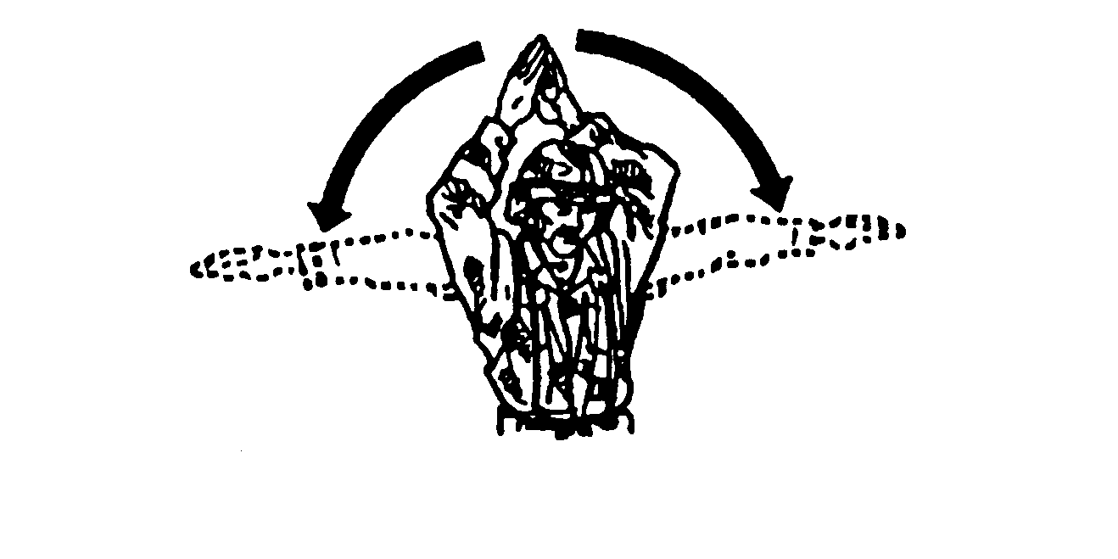
Extend the arms overhead, palms inward, then slowly lower arms to a horizontal position.

Figure 24. Open up.

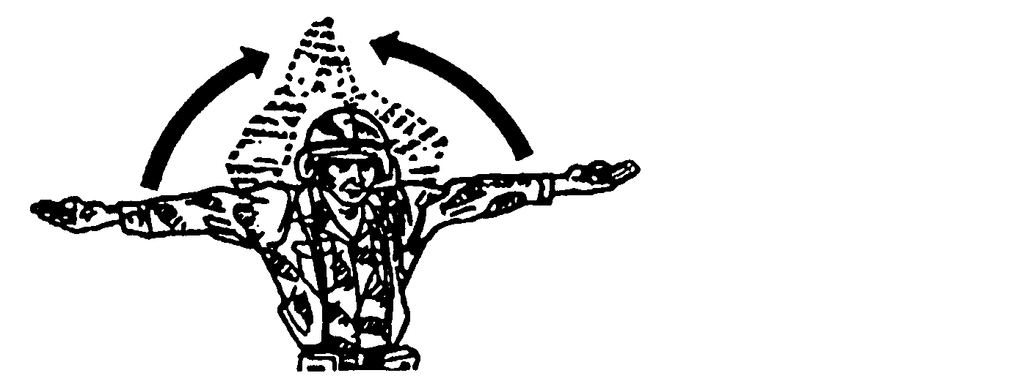
Extend both arms parallel to the ground, palms up, then move the arms up-ward and inward toward the head.

Figure 25. Close up.

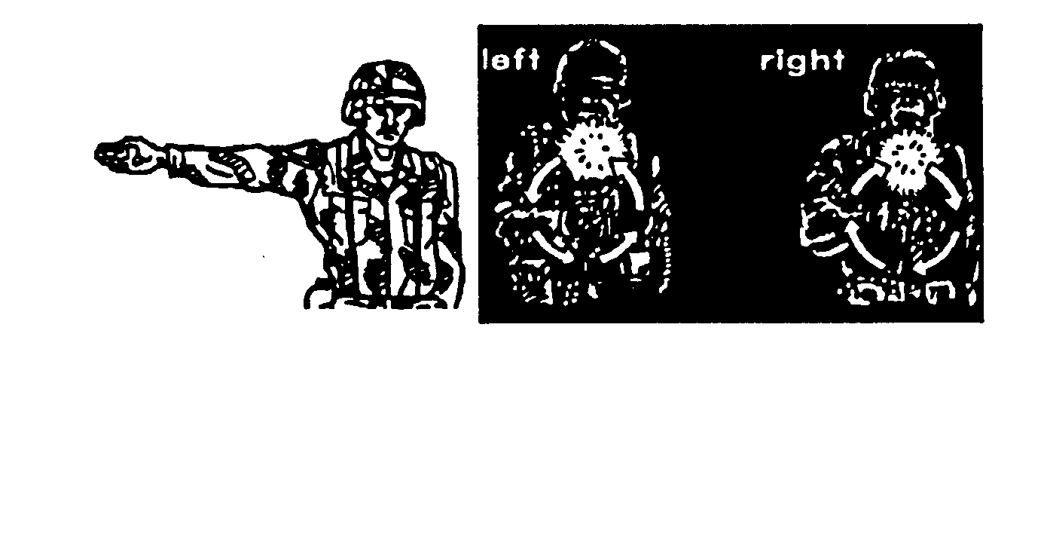
DAY

Extend the arm horizontally to side, palm outward.
NIGHT

Rotate a light to describe a circle 12 to 18 inches in diameter in the direction of the turn.
Left

Figure 26. Right or left turn.

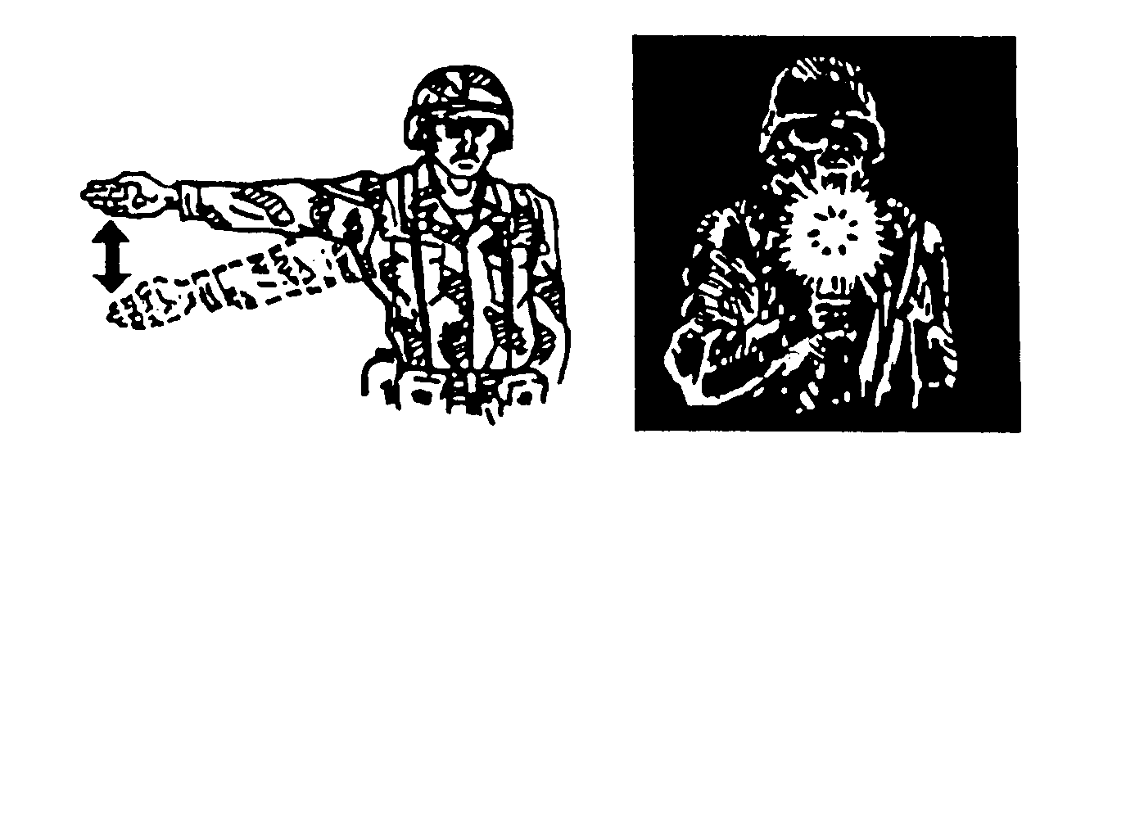
DAY

Extend the arm horizontally to the side, palm to the front; wave the arm slightly downward several times, keeping the arm straight. Do not move arm above horizontal.
NIGHT

Hold a light at shoulder level; blink it several times toward the vehicle.

Figure 27. Slow down.

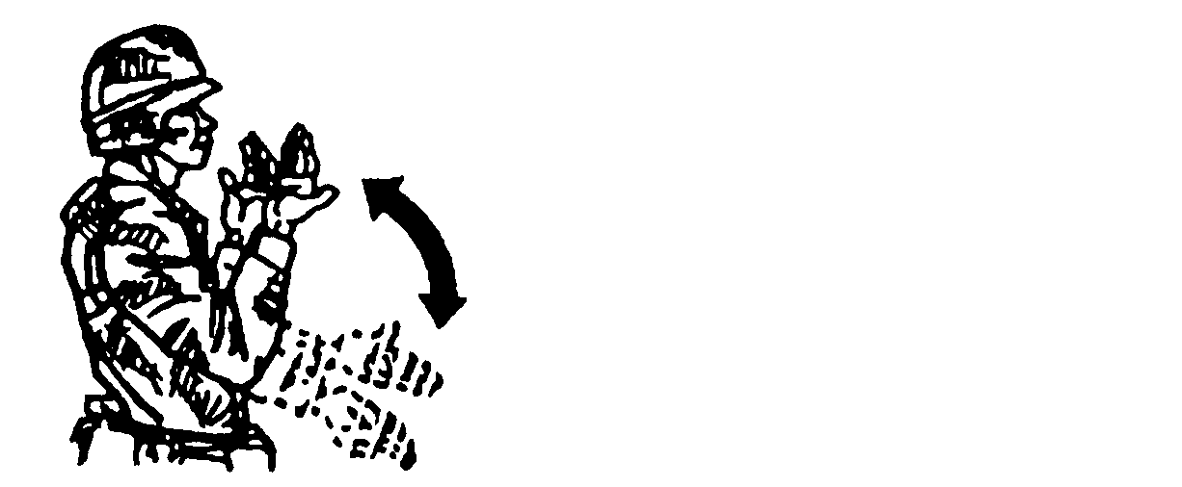
Move the hands and forearms backward and forward, palms toward the chest.

Figure 28. Move forward.

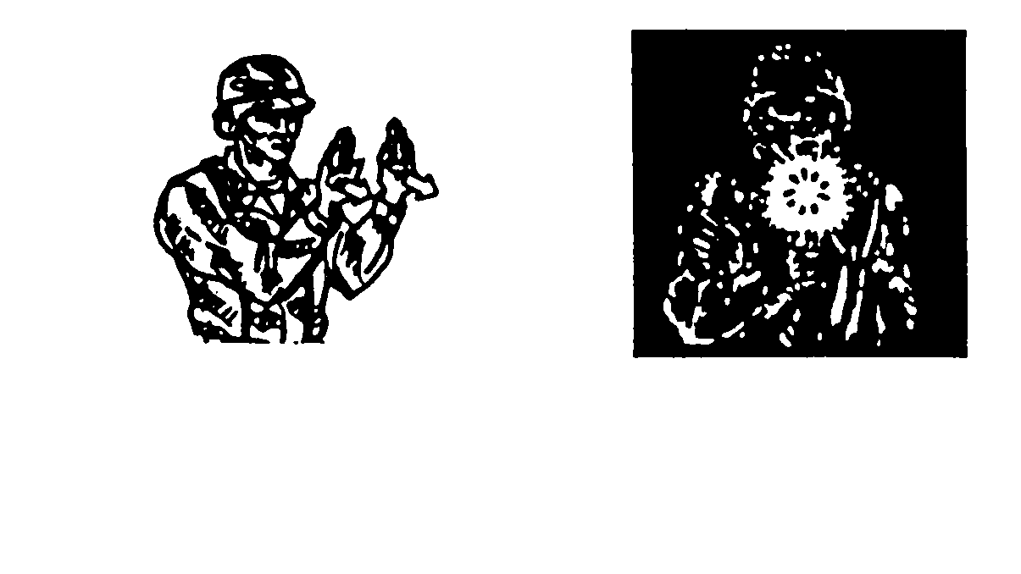
DAY
Face the vehicle(s) (unit) being signaled, raise the hands to shoulder level, palms to the front. Move the hands forward and backward.
NIGHT
Hold a light at shoulder level; blink it several times toward vehicle(s).

Figure 29. Move in reverse (for stationary vehicles).
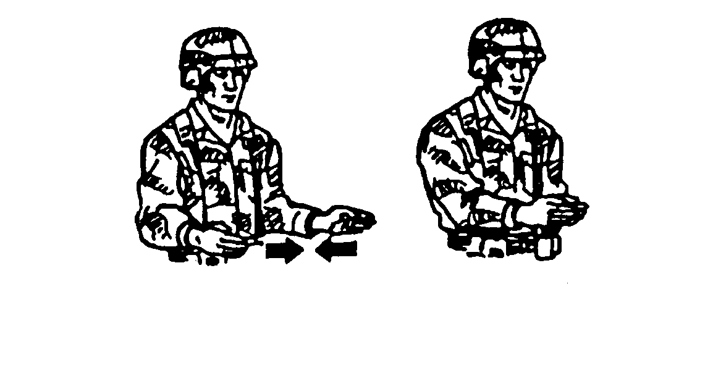
Face the vehicle(s) being signaled, extend the forearms to the front, palms inward and separated (width of the shoulders). Bring the palms together as the vehicle(s) approaches. The vehicle(s) must stop when the palms come together.

Figure 30. Close distance between vehicles and stop.

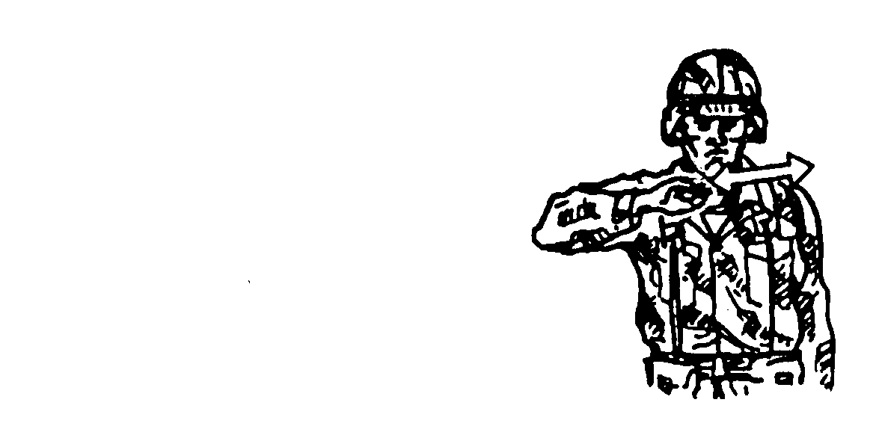
Extend the arm parallel to the ground, hand open, and move the arm across the body in a throat-cutting action.

Figure 31. Stop engines.

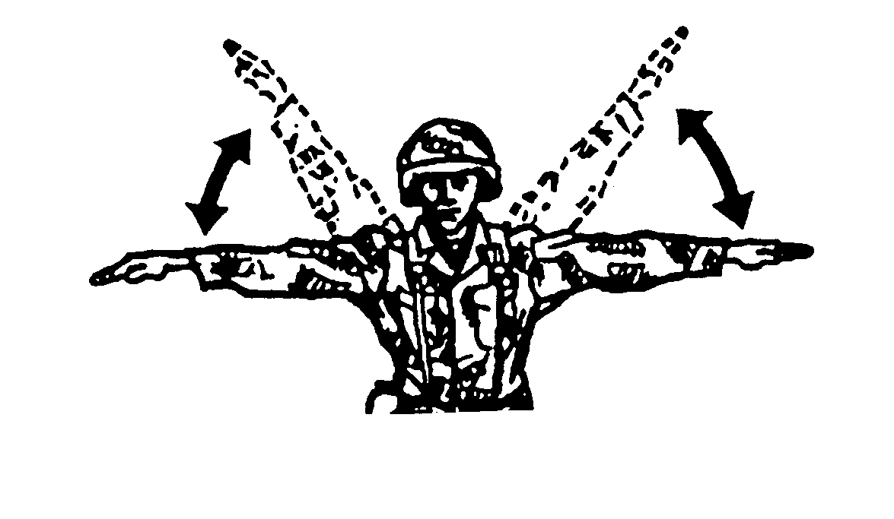
Extend the arms, make two or three movements up and down, hands open toward ground.

Figure 32. Dismount.

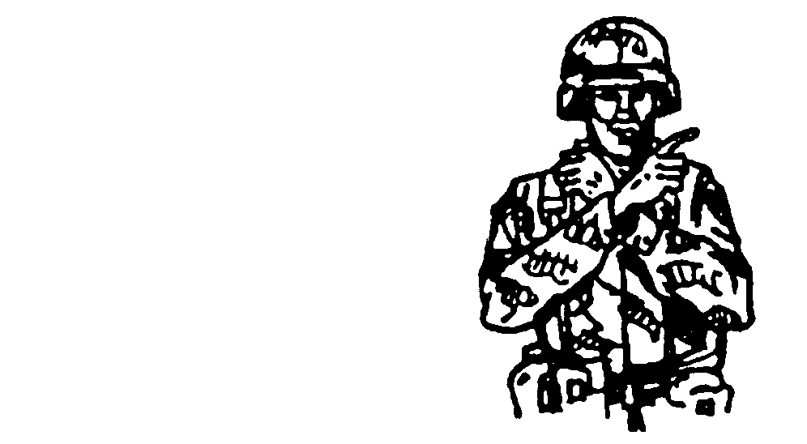
Cross the wrists at the throat; point the index finger in direc-tion of steer. Make a fist of the other hand.

Figure 33. Neutral steer (track vehicles).

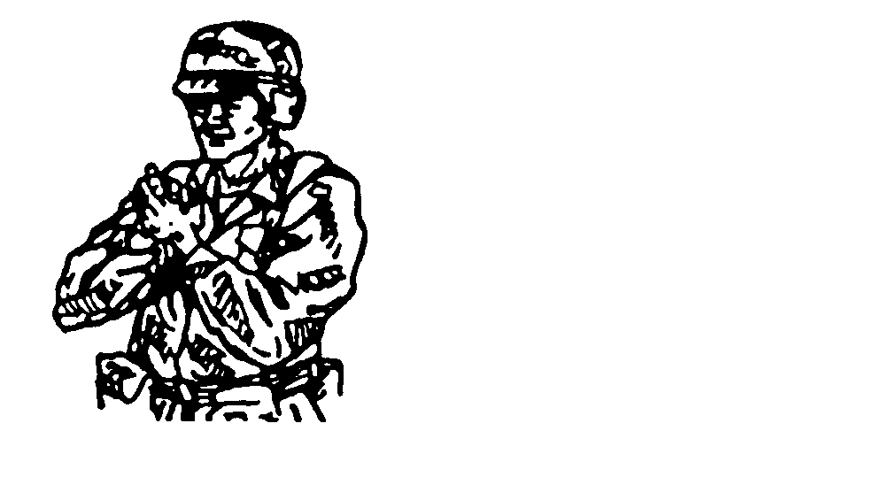
Clasp the hands together, palms facing, at chin level.

NOTE: For an alternate signal to stop vehicles, see Figure 21.

Figure 34. Stop (alternate signal to stop track vehicle).

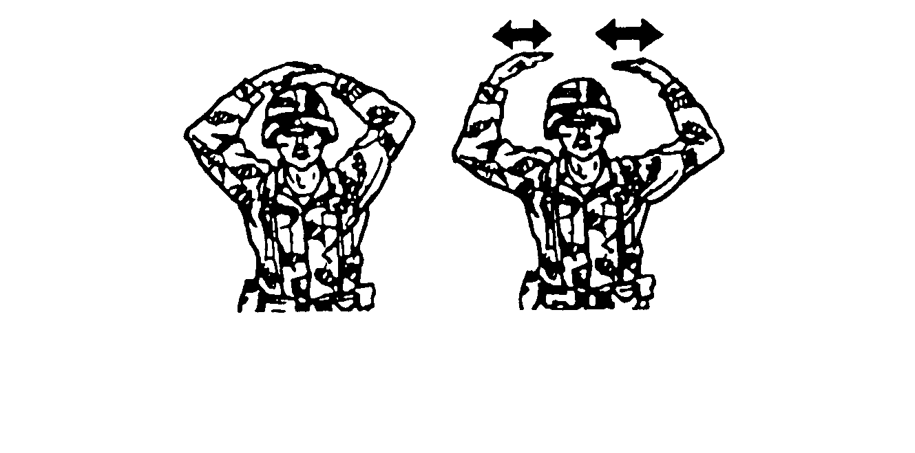
BUTTON UP
UNBUTTON
For BUTTON UP, place both hands, one on top of the other, palms down, on top of the helmet. The arms are back and in the same plane as the body.
For UNBUTTON, give BUTTON UP signal, then separate the hands, moving them to each side in a slicing motion; repeat.

Figure 35. Button up or unbutton.

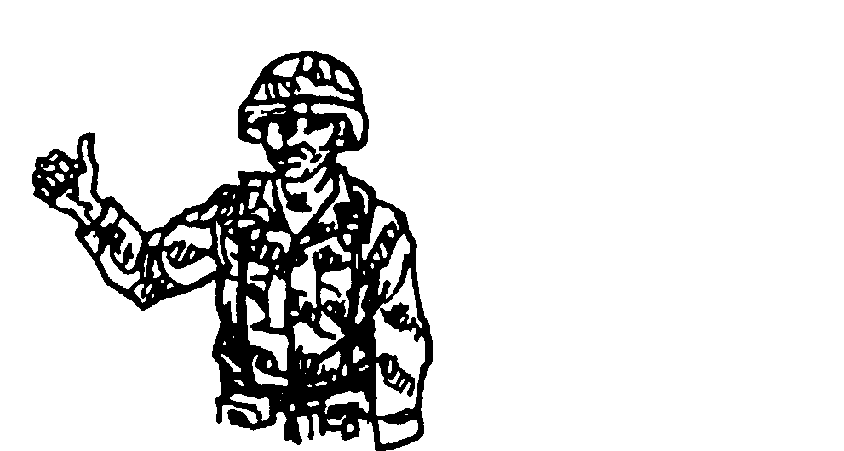
Hold the fist out with the thumb up.

Figure 36. Message acknowledged.

c. Flags (Figures 37 through 43) are used to mark vehicle positions (for example, a quartering party member uses colored flags in an assembly area to mark positions), identify disabled vehicles, warn friendly elements of an advancing enemy (for example, an observation post uses a flag to signal a platoon to move to its fighting position), and control movement (flags serve as an extension of arm-and-hand signals when distances between vehicles become too great).
(1) When used alone, flag colors have the following meanings:
(a) Red—danger, or enemy in sight.
(b) Green—all clear, ready, or understood.
(c) Yellow—disregard, or vehicle out of action.
(2) During poor visibility, colored chemical lights or flashlights with colored filters may be substituted for flags.

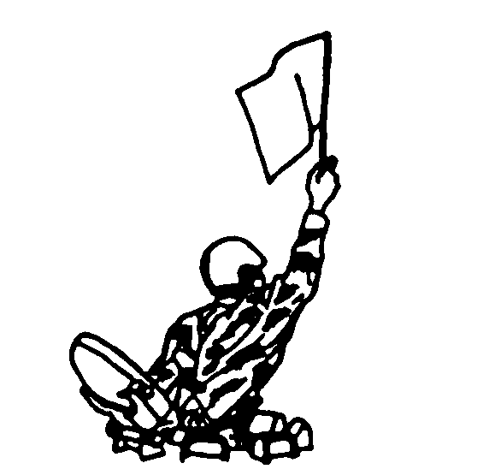

Figure 37. Use a single signal flag.

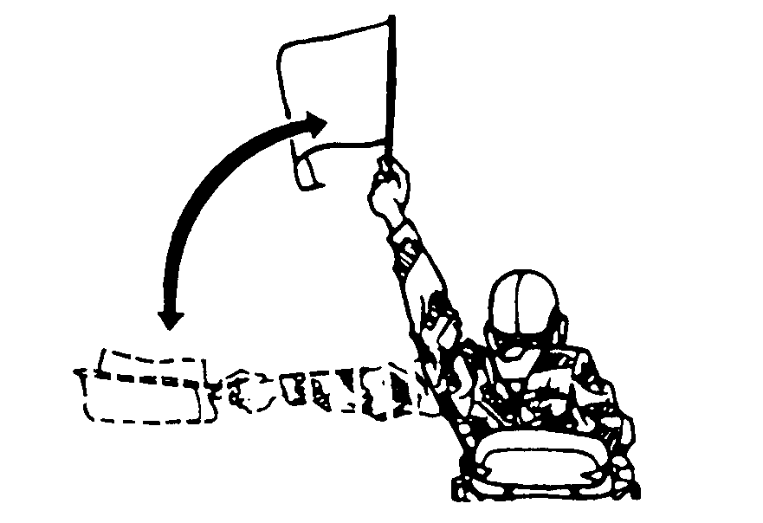
YELLOW

Figure 38. Mount.

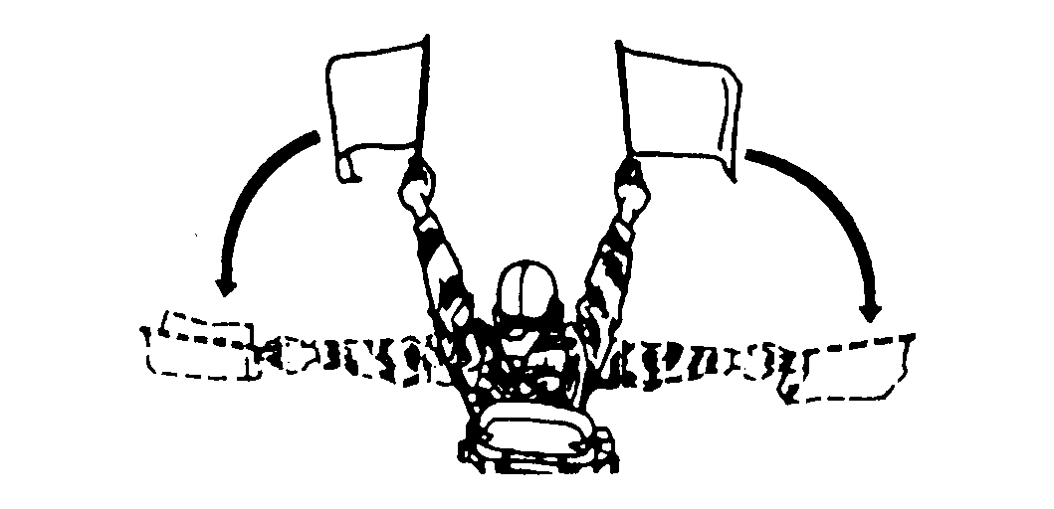
YELLOW
GREEN

Figure 39. Dismount.

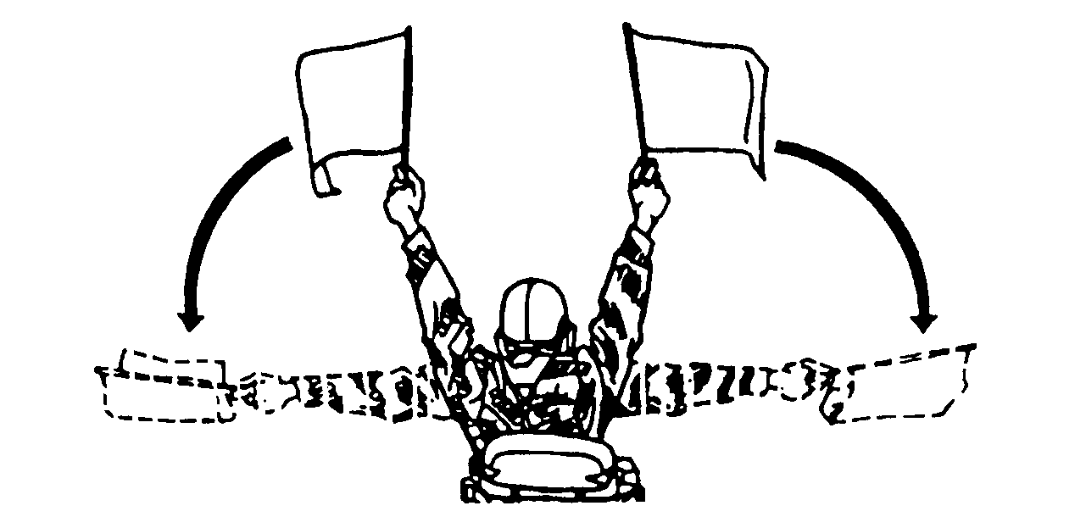
GREEN
RED

Figure 40. Dismount and assault.

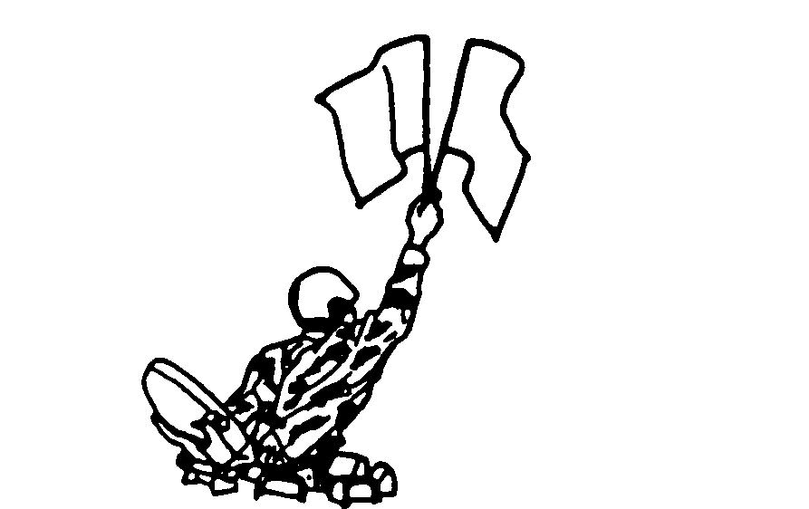
YELLOW
GREEN

Figure 41. Assemble or close.

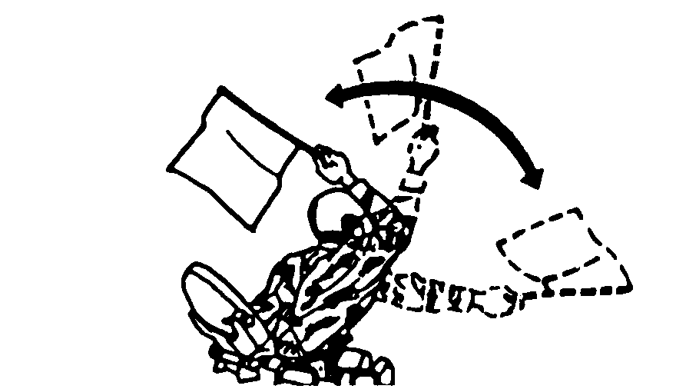
GREEN

Figure 42. Move out.

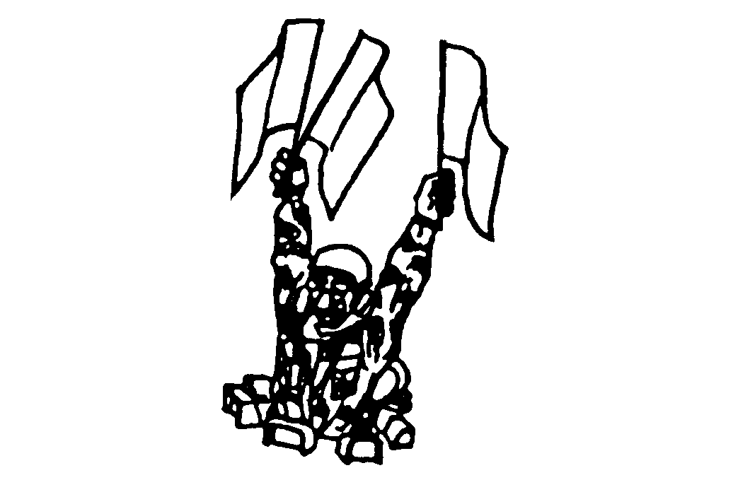
YELLOW
RED
GREEN

Figure 43. Nuclear, biological, chemical hazard present.

EVALUATION PREPARATION

Setup: At the test site, provide a set of vehicle signaling flags and flashlight. From the signals shown in the task, pick 10 to be tested.

Brief Soldier: Tell the soldier that you will give the 10 signals and that he must correctly identify each one.

EVALUATION GUIDE

Performance Measures Results

Identify all signals. P F

FEEDBACK

Score the soldier GO if all steps are passed. Score the soldier NO-GO if any steps are failed. If the soldier fails any steps, show what was done wrong and how to do it correctly.

REFERENCES

Required Related
None FM 7-7
FM 17-95
FM 21-60

